The Alarming! Docklet User Manual
By Miles Rausch

In the following document, I will step you through proper use of the Alarming! Docket for Objectdock, written by Miles Rausch. In a tutorial style, I will show you, in three main areas, how to install the docklet, how to use the docklet, and how to remove the docklet.

Before We Begin

The Alarming! Docklet runs in a program called Objectdock. Objectdock is a program written for computer running the Windows operating system which will emulate the Mac OS X dock. A docklet is a smaller program designed to run in Objectdock. To install any docklet, you must have the program Objectdock installed on your computer. You also must have downloaded the Alarming! Docklet zip file.

Installing the Docket

First, you should download the Alarming! Docklet zip file. This has all the files necessary for installing the docklet, plus files for compiling the docklet yourself, using the C++ compiler in Visual Studio .NET. You will notice that one of the folders is titled "Alarming".

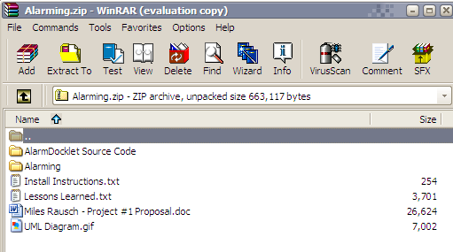

I extract the folder titled "Alarming" to the "Docklets" folder in the Objectdock folder. That path for me is "C:\Program Files\Stardock\Objectdock\Docklets". A dock cannot use a docklet unless its files are contained in the "Docklets" folder. This is why we have to extract these files to that location. This is all that is necessary for "installing" the docklet.

Using the Docklet

To use the docklet, you must first add it to your dock which may look like this.

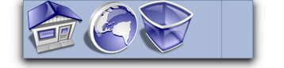

- Then I right-click the docklet
- I mouse over "Add >"
- I click "Alarming! Docklet".
- An alternative way is to right click the dock
- Click "Dock Settings..."
- Click the "Docklets" tab
- Select the Alarming! Docklet
- Finally, click the "Add this Docklet to Dock" button.

Whichever method you use, your dock might look like this.

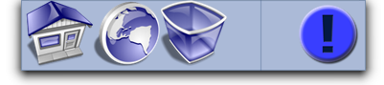

If you've just added the docklet to your dock, you can simply click the docklet to configure it. Otherwise, you can right click the docklet and select "Configure Your Alarm". This will bring up a dialog box where you are able to configure the docklet. The dialog box will look like this.

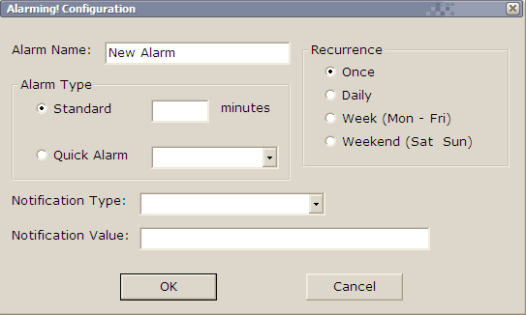

I then entered in the following information.

- Alarm Name: Finish Project
- Alarm Type: Standard
- Minutes: 28
- Recurrence: Once
- Notification Type: Pop up a message
- Notification Value: Your project is done, now.

My configured docklet looks like this.

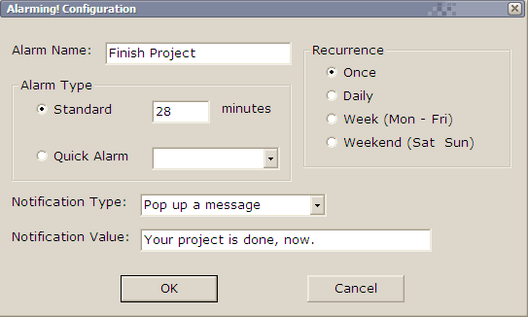

Clicking "OK" will save the configuration. Now, whenever you mouse over the docklet, it tells you the name of the alarm and how long it lasts. For me, it says, "Finish Project lasts 28 minutes." If you click the docklet again you get the "Cancel Alarm" dialog.

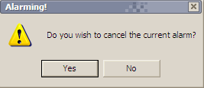

If you right click the docklet you get the "Configure Your Alarm" option and the "Cancel Current Alarm".

After 28 minutes has elapsed, our alarm determines how to notify us. My pop up message looks like this.

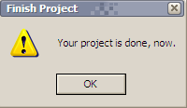

Removing the Docklet

With my alarm finished, the docklet will erase most of the information in the docklet, unless I set a recurrence option different than "Once". Because I only needed my alarm for one simple task, I can now feel safe removing it from the dock. I do this simply by clicking and holding the docklet, and then dragging the alarm docklet off of the dock. It should disappear in a puff of tiger-printed smoke.

Experiment with the different types of notification types and recurrences. To add more than one alarm at a time, you can simply add another docklet. This simple, easy-to-use docklet is sure to be a quick solution to burnt pizza and missed television programs.

Enjoy!

